 | Calendar
Apr 28 | Pickleball - Sunday | 6:00
Apr 30 | Community Services Open Tuesday | 2-5
Apr 30 | Pickleball – Tuesday | 6:30
May 1 | Prayer Meeting – EW | 6:00
May 2 | Community Services Open Thursday | 9-1
May 2 | Pickleball – Thursday | 6:30

Birthdays – April 30 – Keith Clifton
May 3 – Mindy Morgan

Church Budget
Monthly Budget | $9,830.00
Month to Date 04/19/24 | $2,425.99
Under Year-To-Date | $11,794.13
Remember Online Giving!

Other Financial Needs:
Springs of Life - $200/mo.
“The Love of the Truth”
April 27, 2024
Jellico Christian Radio 96.5 FM $350/month.

Next Sabbath
May 4, 2024
Speaker | Steve Boone |  | Song Leader
Elder | Danny Chacko |  | San. Teacher | Regina E.
Offering | Church Budget |  | Potluck | General

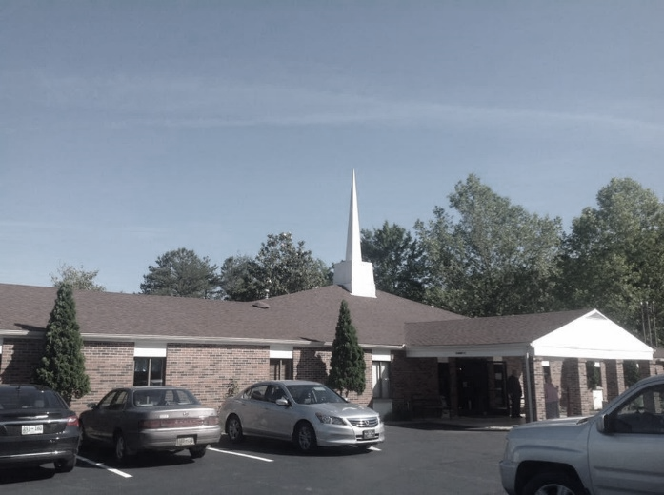
Jellico
Seventh-day Adventist
Church
“The Love of the Truth”
Jellico SDA Church
April 27, 2024

Announcements |  |  |  |  |  | Steve Boone
Prelude |  |  |  |  |  | Bonnie Towles
Call to Worship |  |  |  |  |  | Steve Boone
Opening Hymn |  |  | “Love Divine” |  |  |  |  |  |  | #191
Pastoral Prayer |  |  |  |  |  | Steve Boone
Offering |  |  |  | Cohutta |  | Steve Boone
Offertory |  |  |  |  |  | Bonnie Towles
Doxology/Prayer |  |  |  |  |  | Steve Boone
Special Music |  |  |  |  | Sarah Neacsu
Scripture |  |  | 2 Thessalonians 2:8-10 |  |  |  | Steve Boone
Sermon | “The Love of the Truth” |  |  |  |  |  |  | Chris Spinolo
Closing Song |  | “More Love To Thee” |  |  |  |  |  |  | #489
Closing Prayer |  |  |  |  |  | Chris Spinolo
Postlude |  |  |  |  |  | Bonnie Towles

Sunset Today: 8:20 pm Sunset Friday: 8:26 pm

Welcome to the Jellico Seventh-day Adventist Church. We hope you have a blessed Sabbath! Please join us for a Fellowship Meal in the gym.

Bulletin Secretary is Cheryl McDaniel – Please text bulletin information to 423-494-1532 by Thursday evening.
Announcements

JCA Graduation – May 24

Jeremiah 29:11 - For I know the thoughts that I think toward you, saith the Lord, thoughts of peace, and not of evil, to give you an expected end.
The Prayer Corner
Please Pray For Be Thankful for
Craig and Karen Taylor as they adjust to their new home.  Robby – health issues.  Mrs. Wells – death of her father. Thankful that she will see him in heaven! Praying for safety as family moves.  Mrs. Wells friend that had a pacemaker put in last week.  Vicky – health problems.  LeRoy Ruiz, our trash collector – was in a serious accident.  Sale of Taylor’s House  Kathy Gimble’s Parents - health  New Pastor |  | Mark’s sister and the healing she is feeling!  Community Services – Thankful for our Volunteers! Praying for more.  Evangelistic meetings that Elder Green is leading out in in Jackson, KY.  Dan Gimble – Safety in travel.  Bob Penn – cataract surgery

